Introduction
The purpose of this user’s manual is to help you to navigate through the Kayako Solutions help desk.

Login Page
On the login page you must enter your username and password to be able to enter the system.
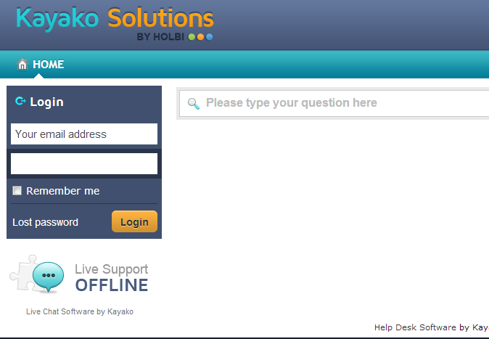
In order to enter the system without further authentication, mark the checkbox Remember me.

Home page
On the home page you can enter or change the necessary information about your profile, organization and preferences, as well as to change your password if required.
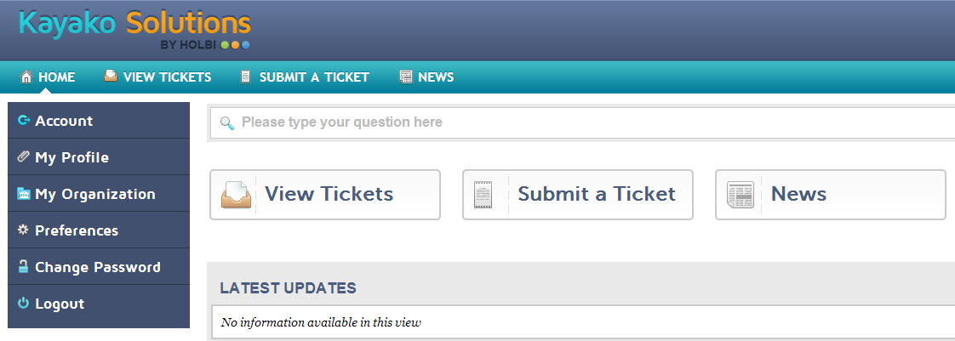

In the middle of the screen you can see the options View tickets, Submit a ticket, and News. You can access any of the options by clicking on the appropriate button.

View tickets
In the section View tickets you can see all the submitted tickets and their details.
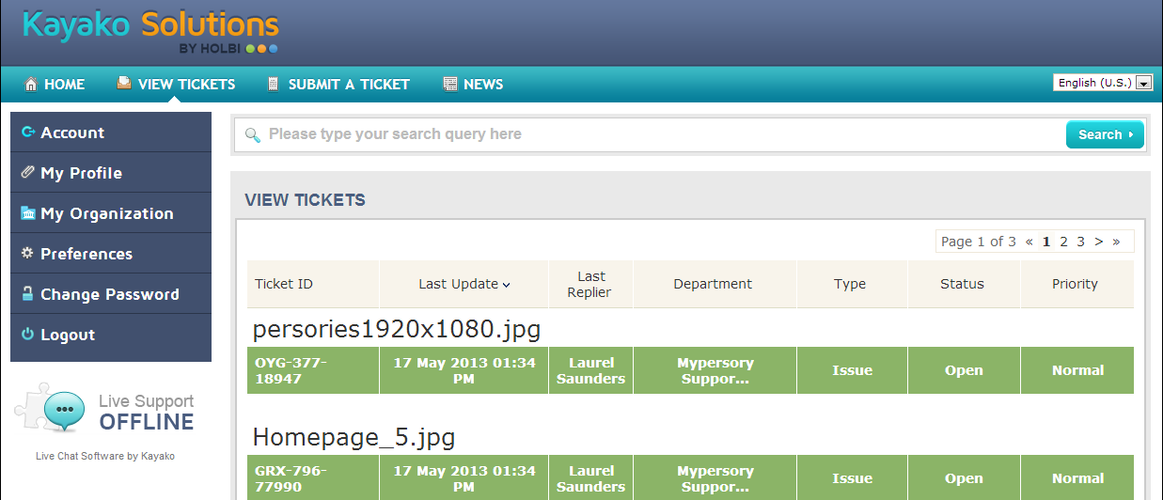

You can find the necessary ticket by entering the name of the ticket or a part of it in the Search field. When you find it, click on the name of the ticket to see its description and other details.
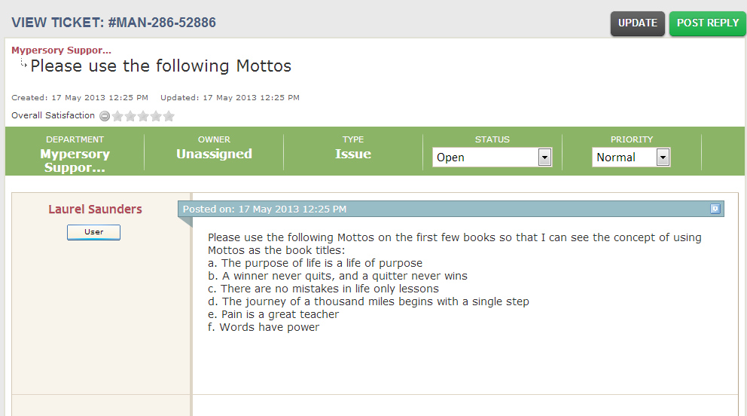
Submit a ticket
In order to submit a new ticket, go to the section Submit a ticket and click the button Next.

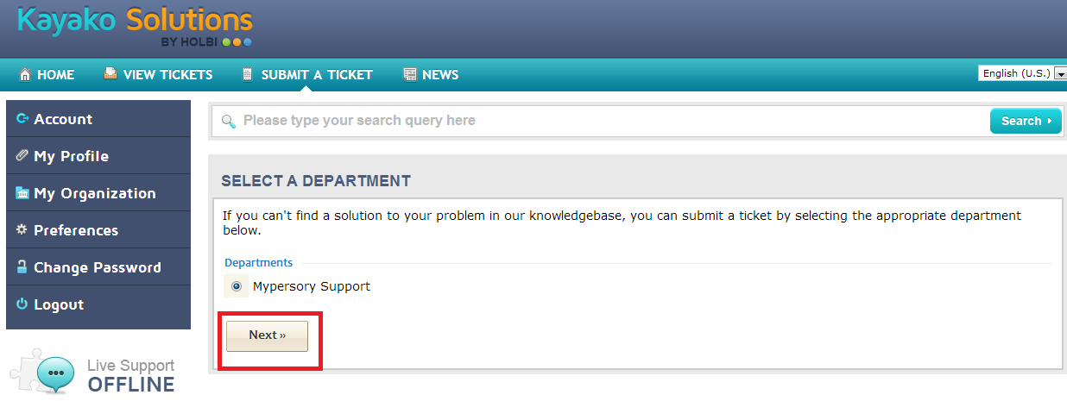

In this window you have to specify the subject and description of the ticket, since these fields are required for submitting a ticket. You can also upload the file by clicking on the button Add file and choosing the file needed.
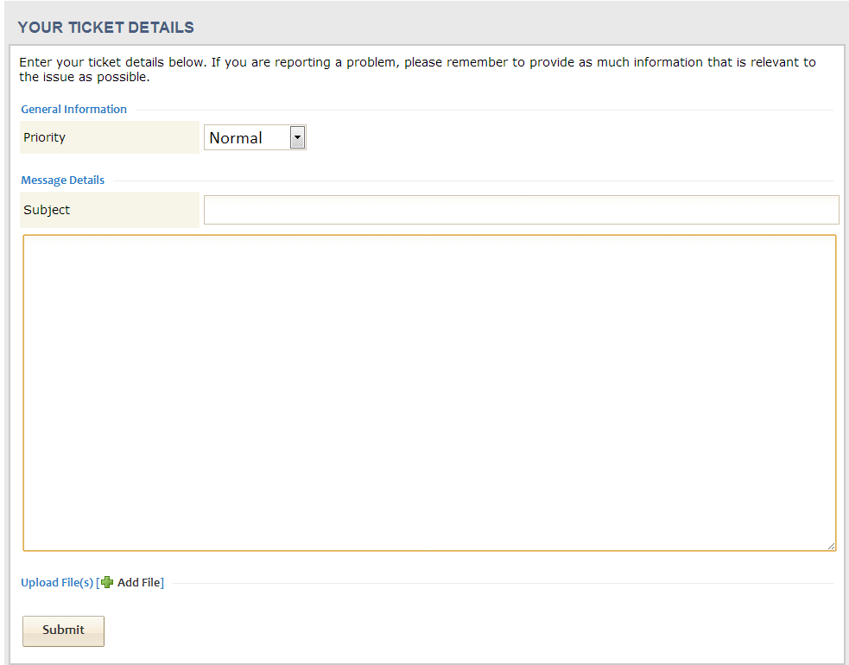

Once the ticket is received, our help desk staff reviews, works and comments on the ticket.
News
In the section News you will be able to see all the notifications sent to you when any updates are made regarding any of your tickets.

